**The Plan-It-Right Mobile Application Development Project**

**Final Report**



**Course: CSTP 2204**

**Instructor: Xing**

**Group Members: Harleen, Eric, PoKai**

**Date: Dec 9th, 2021**

# Table Of Contents

Table Of Contents 1

Chapter I: Project Description 5

Background 5

Motivation 5

Goals and Objectives 6

Market Research 6

A. Basecamp 3 7

B. To-Do List - Schedule Planner & To-Do List Task Manager 8

Market Research Conclusion 8

Chapter II: Project Plan 10

Project Plan Summary 10

Project Deliverables 11

1. Software 11

2. User Guide 11

Project Schedule 11

Project Success Criteria 11

Project Team Organization Chart 12

Project Communications 13

Project Tools for Application Development 13

Chapter III: Project Requirements 15

Application Environment Constraints 15

Non-Functional Requirements 15

Operational Requirements 15

Performance Requirements 16

Security Requirements 16

Functional Requirements 16

Chapter IV: Project Design 20

Mobile Application Architecture 20

Data Storage 20

User Interface Design 21

Color Palette 21

Screen Designs 22

Login Screen 23

Registration/Signup Screen 24

Main Screen 25

New Project Screen 26

Project Detail Screen 27

Project Detail Edit Screen 28

New Task Screen 29

Chapter V: Project Class Diagrams 30

Model and Repository Classes 30

View Classes 32

Controller Classes 34

Chapter VI: Test Results 35

User Testing 35

Testing 1: Login to the application 35

Testing 2: Create Account 36

Testing 3: Create a new project 37

Testing 4: Edit Project 38

Testing 5: Create New Task 40

Testing 6: Edit Project Task 42

Chapter VII: User Guide 44

Installation Guide 44

Step 1: Install Expo Go 44

Step 2: Install Plan-It-Right 44

Operational Guide 48

Creating a New Account 48

Logging into the application 49

Logging out of the application 50

Creating a New Project 50

Viewing Project Details 51

Updating a Project 52

Adding a New Project Member 53

Promoting a Project member to Project owner 54

Deleting a Project 55

Creating a Task 56

Viewing Task Details 57

Updating a Task 58

Changing Task Status 59

How to Modify Task Status 60

Changing Task Status to Backlog 60

Changing Task Status to In Progress 61

Changing Task Status to Completed 62

Deleting a Task 63

Chapter VII: Conclusion 64

Lessons Learned 64

Challenge 65

Future Improvements 66

Chapter VIII: References 67

Chapter lX: Appendices 68

Chapter 0: Overview

This final report presents a detailed description of the Plan-It-Right mobile application development project. This report is divided into 9 chapters in the following order: Project Description, Project Plan, Project Design, Project Implementation, Test Results, User Guide, Conclusion, Reference, and Appendices.

# Chapter I: Project Description

### Background

As sophomore students in Vancouver Community College, we understand how hectic life can be. Not only do we have to beat the stress from school assignments, group projects and exams, many of us also have a second life beyond academia. Some of us have part-time jobs and some of us need to take care of family members. Finding ways to prioritize our tasks and keep track of our daily responsibilities are crucial to our productivity and well-being.

### Motivation

At the beginning of this project, we asked ourselves what kind of application we can create to help people to stay on top of all the important things in their lives. We thought making a productivity tracking application would be a great idea. A simple tool like the to do list can drastically improve our productivity and lives.

We wanted to make a mobile application that allows people to enumerate all their daily tasks in an organized manner. This way, people can stay focused on what matters the most at hand and free up their mind for creativity. When people complete a task, they can check off the task from the to do list. This will give people a sense of progress and achievement.

Furthermore, we wanted this application to be able to manage group projects, where all the group members can manage and collaborate on group tasks. When one member adds a new task to a project, all project members can get update for the new task instantaneously.

### Goals and Objectives

In this project, our team wants to develop a mobile application that can help users to manage their projects and keep track of their daily tasks. This application is aimed for users who either own an Android or IOS mobile device. We want our application to satisfy the following goals:

1. A simple and easy to use interface
2. Tasks should be fast to add into a project
3. Task status is clearly indicated as being backlog, in-progress, or completed
4. Tasks in a project should be able to be filtered by task status
5. For a group project, the project owner should be able to assign which project member to do the task
6. The application should work on both the Android and IOS platforms

### Market Research

Our team has conducted research on some of the most popular project management applications on Google Play Store. Two noteworthy project management applications are *Basecamp 3* and *To-do list*. Both have ratings over 4.0. The following are the analyses of both mobile applications:

#### Basecamp 3

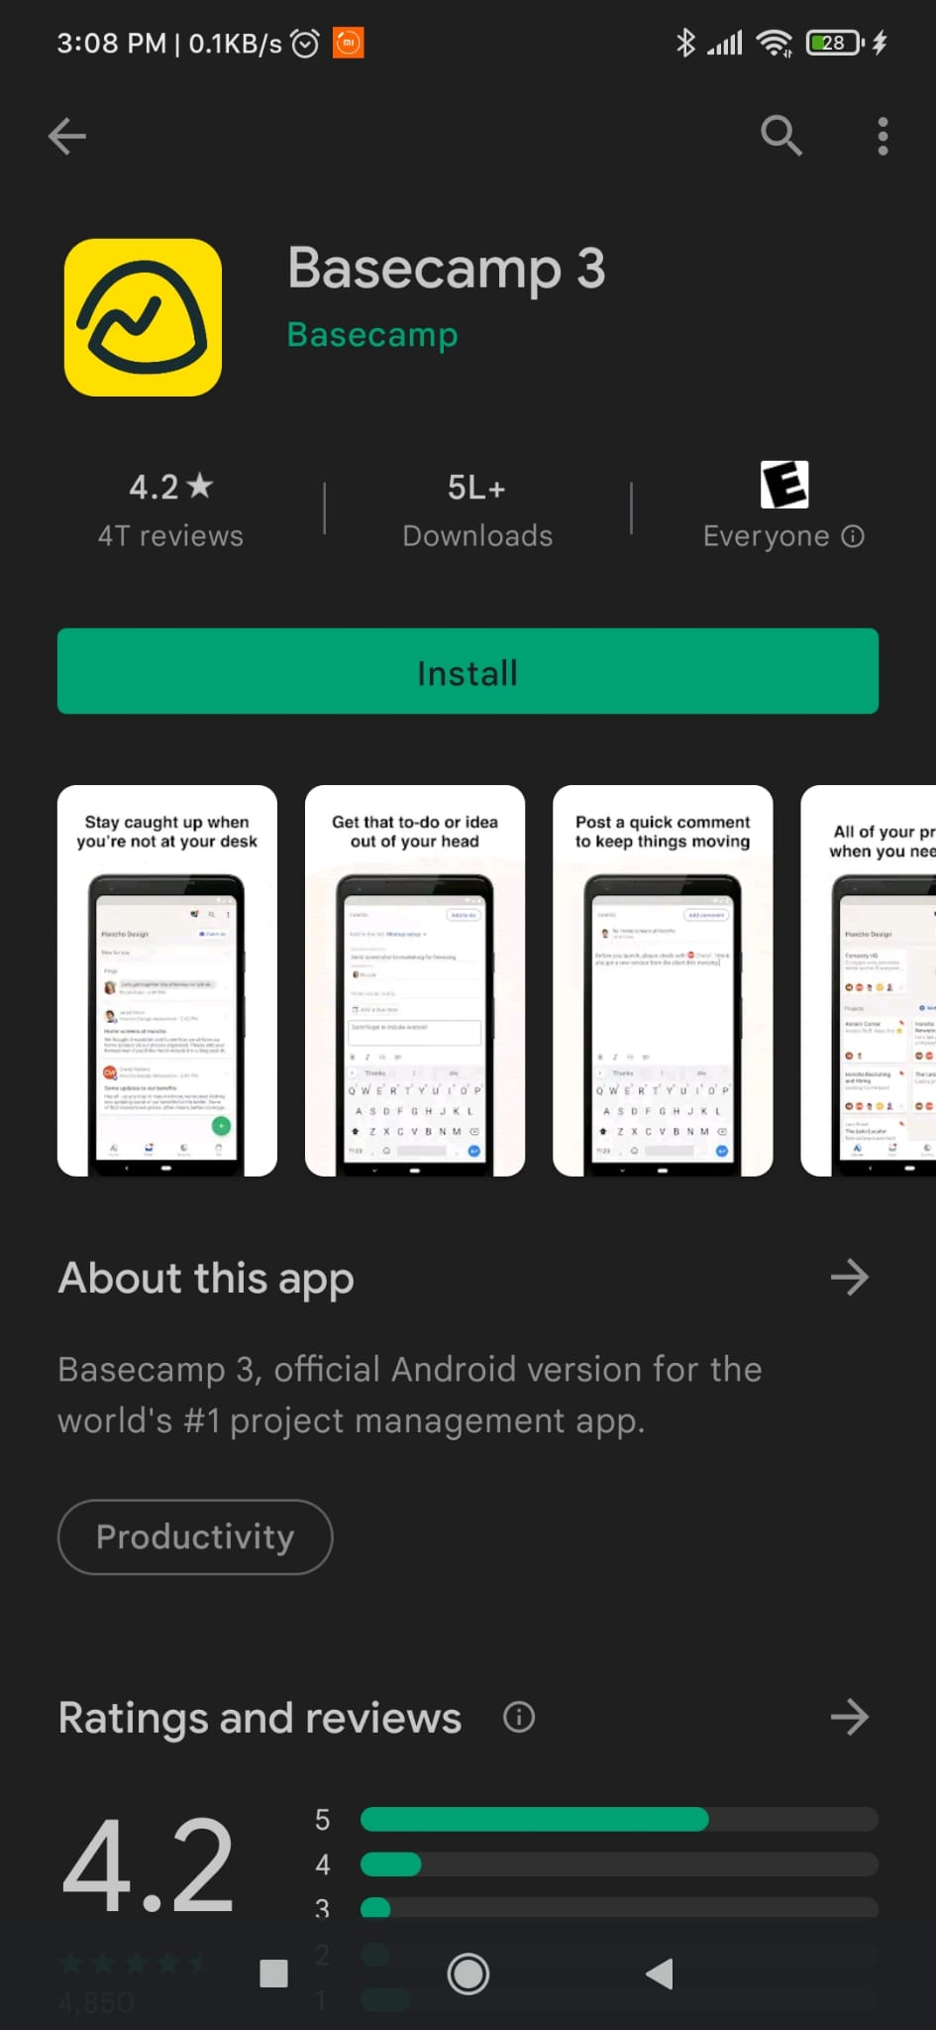

*Figure 1.1: Basecamp 3 Installation on Google Play Store*

*Basecamp 3 (Figure 1.1)* helps users to manage their projects and teams within one application. It combines all the tools like emails, chat threads, word docs etc. in a single straightforward package which makes the work easy and organized. It has a rating of 4.2 in Google Play Store. Please refer to *APPENDIX 1.1* for a screen capture of this application.

**Strengths:**

* Excellent workflow – easy to use for huge workspace
* Works on both – Mobile and Desktop
* User Friendly
* Well organized and intuitive

**Downsides:**

* Requires subscription - $99/month (see *APPENDIX 1.2*)
* Some features like “Chatting” do not work fine

#### To-Do List - Schedule Planner & To-Do List Task Manager

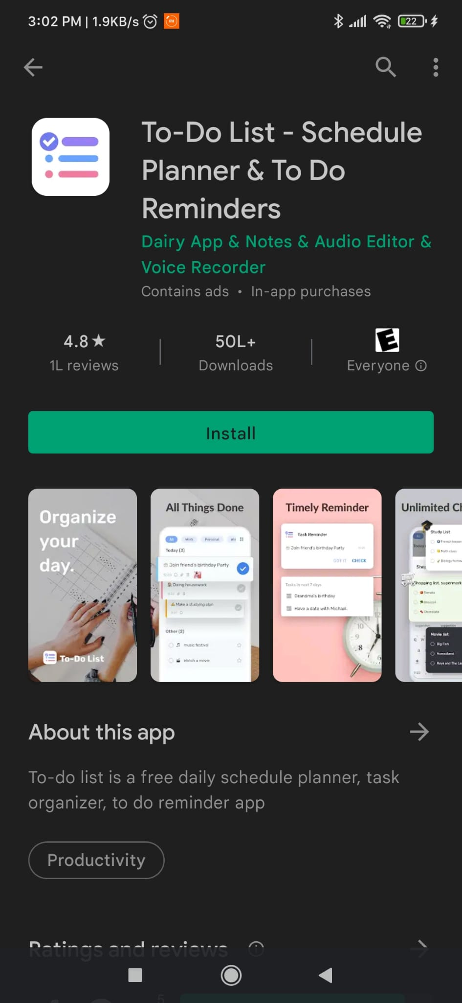

*Figure 1.2: To-Do List Installation on Google Play Store*

*To-Do List - Schedule Planner & To-Do List Task* *Manager* is an easy online to-do List task manager and schedule planner app that can be used to manage tasks and time this application. It has a rating of 4.8 in Google Play Store. Please refer to *APPENDIX 1.3* for a screen capture of this application.

**Strengths:**

* + Easy to use.
  + Minimum number of ads
  + Well designed and intuitive

**Downsides:**

* Requires Subscription/ Premium that is not affordable for everyone (see *APPENDIX 1.4*).
* There are many bugs in the application that users complained about.

#### Market Research Conclusion

There are many project management applications available in the market. Surprisingly, some of them demand a steep monetary subscription. Basecamp requires a $99 monthly subscription. This is not a reasonable price that an average user is willing to pay.

We want to offer our project management application free of charge for our users. We believe simple tools like a project planner should not cost user a fortune! Plan-It-Right will be ideal for students or anyone who wants to start up personal projects. Also, our mobile application will be great for small teams.

# Chapter II: Project Plan

### Project Plan Summary

Our project was divided into 4 development phases/milestones: the planning, application development, testing and closing phases. Please refer to *APPENDIX 2.1* for our project WBS Diagram.

In the planning phase (from Sept 9 to Sept 28), our team has completed the following documents: specification requirements document (SRD), software project management plan (SPMP) and software description document (SDD).

In the application development phase (from Oct 4 to Nov 16), our team aimed to first complete the frontend UI development, such as implementing the application UI screens, logic and functionalities. After the frontend was completed, the team moved on to implement the backend of the application, such as data storage and authentication with Firebase.

In the testing phase (from Nov 16 to 18), the team conducted user testing and collected feedback from test subjects.

In the closure phase (from Dec 2 to Dec 9), the team completed our first version of Plan-It-Right application on November 25th and user guide on December 2nd.

Finally, our team is expected to deliver our final presentation on December 16th.

### Project Deliverables

#### Software

Our team should complete the Plan-It-Right mobile application on November 25. The deliverable will include the final code of our project application. Our project application source codes will be hosted at the following GitHub repository:

<https://github.com/pokai-huang0828/PlanItRight-project>

#### User Guide

Our team will provide a user guide for the Plan-It-Right mobile application. The user guide will entail all the necessary information about the features and functions that a user can perform on the Plan-It-Right mobile application. Moreover, there will be walk-through illustrations that show users how to perform different actions in our mobile application.

### Project Schedule

Please refer to *APPENDIX 2.2* for our project Gantt chart. It illustrates our project development phases/milestones, planning schedule, duration, and date of completion of each task. You may also find a downloadable version of our Gantt chart at the following link:

<https://1drv.ms/x/s!AgSWbnXU4oIwmzjuI-RneOK9p2Ye?e=NjWmrU>

#### Project Success Criteria

The following are the success criteria for this project:

* Complete all items are in the WBS (refer to Appendix 2.1)
* Deliver all project deliverables in a timely manner
* Maintain a good teamwork environment
* The Plan-It-Right mobile application is easy to use and reliable
* Users can easily install the mobile application
* Users can start the mobile application without crashing

### Project Team Organization Chart

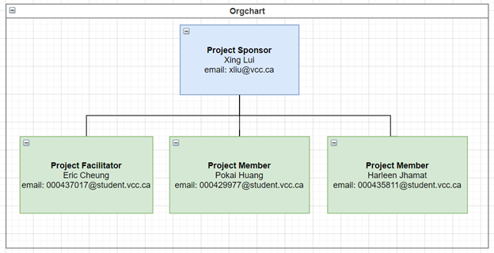

*Figure 2.1: Org Chart*

Figure 2.1 shows the organization chart of our project team. Our project sponsor is Xing Lui, who approves our project scope, schedule, and application specification. Eric Cheung is the project facilitator, who is responsible for overseeing the project progress and developing the mobile application with other project members. Pokai Haung will be responsible for leading project presentations. Harleen Jhamat will be responsible for authoring technical reports.

### Project Communications

All team members will have project meetings every Tuesdays at 10am to discuss project progress and determine the to-do tasks for the following week. Mode of communication includes Discord, WhatsApp, and email.

### Project Tools for Application Development

In this project, our team used Visual Studio Code as our primary code editor. Visual Studio Code is developed by Microsoft (Rawal, 2018). It is a free and open-source code editor. It runs on cross platforms like Windows, Mac, and Linux.

Our team used Expo and React Native to develop our Plan-It-Right mobile application. Expo is a framework and a platform for universal React applications. It is a set of tools and services built around React Native and native platforms that help developers to develop, build, deploy, and quickly iterate on iOS, Android, and web apps from the same JavaScript/TypeScript codebase (Introduction to Expo, n.d.).

As for versioning control tool, our team used GitHub to deposit our application source codes.

Below is a summary specification of the Plan-It-Right application.

|  |  |
| --- | --- |
| **Hardware Platform** | Windows PC |
| **Software Platform** | Windows 10 |
| **Program Language Used** | JavaScript  React.js  React Native  Shell |
| **Development Tools** | VS Code  Expo  Android Studio Emulator  GitHub |

*Table 2.1 Application summary*

# Chapter III: Project Requirements

### Application Environment Constraints

* The mobile application should run on Android 5.0 (API 21) or iOS 11.0 or newer.
* The mobile application should connect to a cloud-based backend (such as Firebase) that can handle user authentication and data storage.
* The mobile application does not need to support data caching. Users will require internet connection to use the mobile application.

### Non-Functional Requirements

#### Operational Requirements

* Authentication is required before users can use any features in the mobile application
* Users will stay logged in unless users decide to log out from the mobile application.
* The sign-up process will only require the user’s email and password.
* Internet access at a minimum 3G speed will be required to communicate with the firebase backend.

#### Performance Requirements

* Any user actions that require a UI response, such as adding a new project or updating project details should be completed in 1000ms (about 1 second).
* Screen transition, such as navigating the user from the login screen to the main screen, should be completed in 500ms.
* This application should accommodate a minimum of 100 registered users.
* A project can be joined by a minimum of 10 users.
* A project should be able to hold a minimum of 100 tasks.

#### Security Requirements

* All data generated from the application, such as user’s projects and tasks should be stored in the firebase backend only
* Only application developers and maintainers should have access to the firebase backend.
* Unauthorized data export from the firebase backend is prohibited.

### Functional Requirements

For the mobile application, there should be two levels of user privileges: project owner and project member. Project owner has a higher privilege than project member. For example, only project owners can assign project tasks to other project members. Each project task can have a status of being *backlog*, *in process* or *completed*. Only project owners or task assignees can modify the status of a project task.

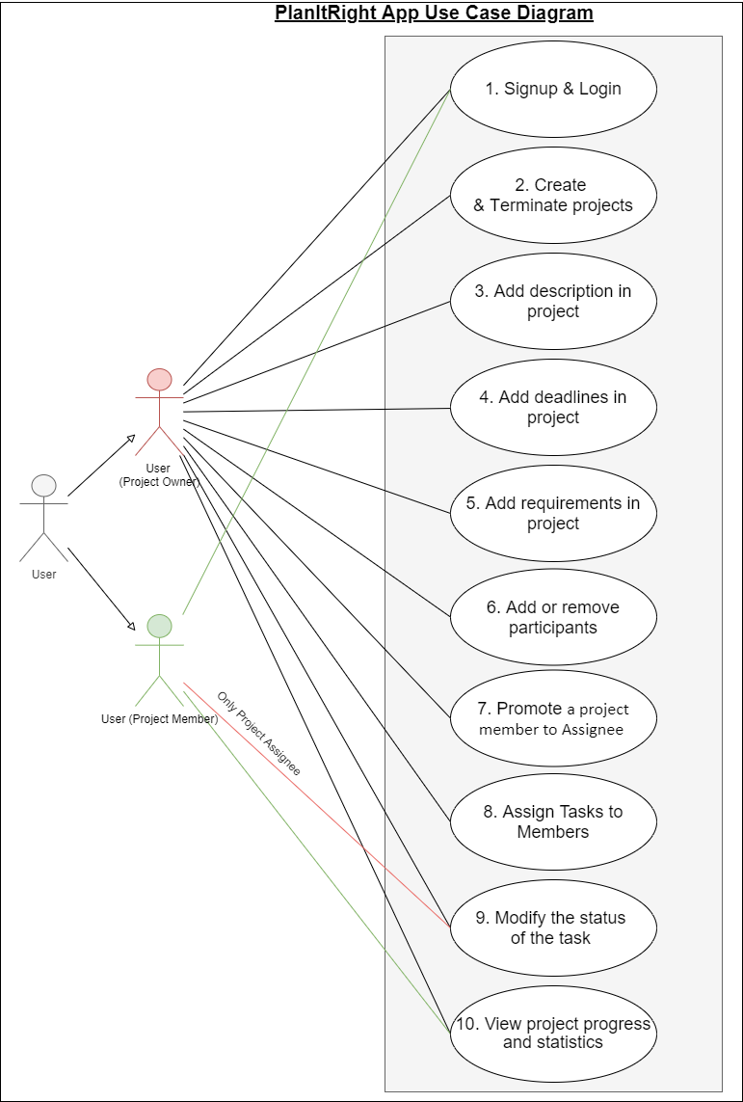

Figure 3.1: Application Use Case Overview

Figure 3.1 shows all use cases of our Plan-It-Right mobile application. The following provide a brief explanation of each use case in Figure 3-1:

1. All application users must sign up and login.

2. Only project owner can create & terminate projects.

3. Only project owner can add project description.

4. Only project owner can add project deadlines.

5. Only project owner can add project requirements.

6. Only project owner can manage project participants.

7. Only project owner can promote any project member to become a project owner. This will allow a project member to receive a higher level of privilege.

8. Only project owner can assign tasks to another participants.

9. Only project owner and the assignee of the project task can modify the status of the project task.

10. All participants in the project can view the project progress and details.

# Chapter IV: Project Design

### Mobile Application Architecture

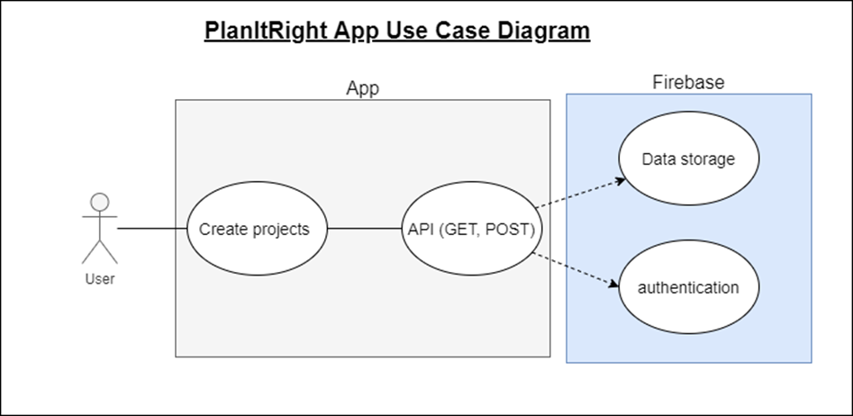

Figure 4.1: Architectural Design Use Case Diagram

Figure 4.1 shows the system architecture of our Plan-It-Right application. Users interact with the application via the mobile frontend, from which the users can manage their tasks and projects. The frontend communicates with a Firebase backend via libraries provided by the vender. Firebase provides backend services to the application including authentication and data storage. Since we are using Firebase, we do not need to set up any physical server to handle API calls or data storage.

### Data Storage

We use Firebase to store our application data. User’s profiles and projects are stored in Firestore.

Our application does not support data caching, which means that users must have internet access to use our application.

Our project uses the free quota offered by Firestore. The free quota limits data traffic at 50,000 document reads per day, 20,000 document writes and deletes per day (Firebase, n.d.).

### User Interface Design

#### Color Palette

We used [Muzli](https://colors.muz.li/) Colors to set up our application’s color palette. [Muzli](https://colors.muz.li/) Colors is a useful website that allows users to discover the best design inspiration and find a suitable palette more quickly. Please visit the following link for more information about [Muzli](https://colors.muz.li/) Colors: <https://colors.muz.li/>

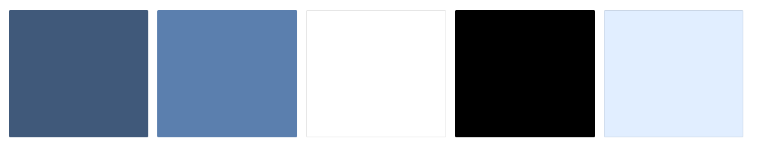

#40597A #5b7fAE #FFFFFF #000000 #ELEEFF

*Figure 4.2:* Color Palette

Figure 4.2 is the schema of our Color Palette. We believe Plan-It-Right should look professional and reliable, so our team has chosen deep navy blue as the primary color tone of the application.

### Screen Designs

In this project, we used [Marvel](https://marvelapp.com/) to design our wireframes. Marvel is a web application that allows users to create beautiful wireframes, mockups, websites, or application prototypes for any device. For more information about Marvel, please visit:

<https://marvelapp.com/>.

All our application wireframes are displayed below. You can also find an interactive UI prototype at:

<https://marvelapp.com/prototype/77d86ca/screen/82324014>

#### Login Screen

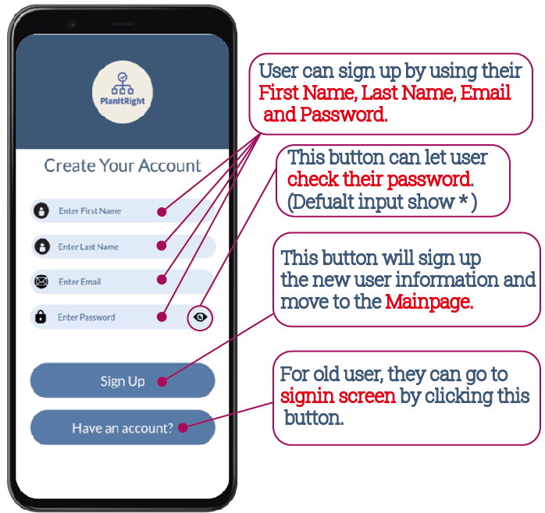

*Figure 4.3: Login Screen*

#### Registration/Signup Screen



*Figure 4.4: Registration/Signup Screen*

#### Main Screen

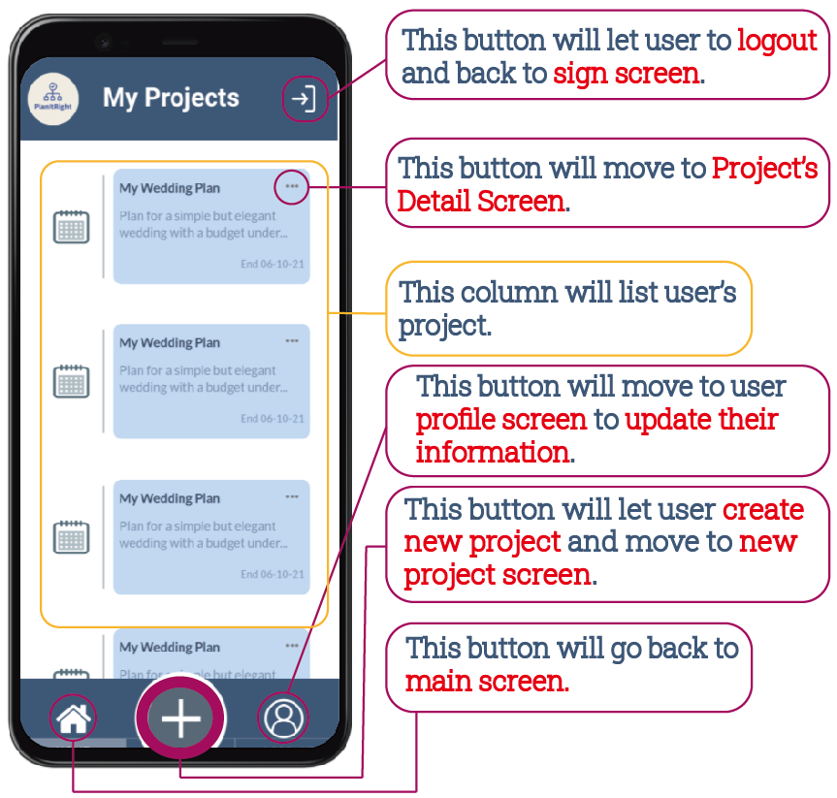

*Figure 4.5: Main Screen*

#### New Project Screen

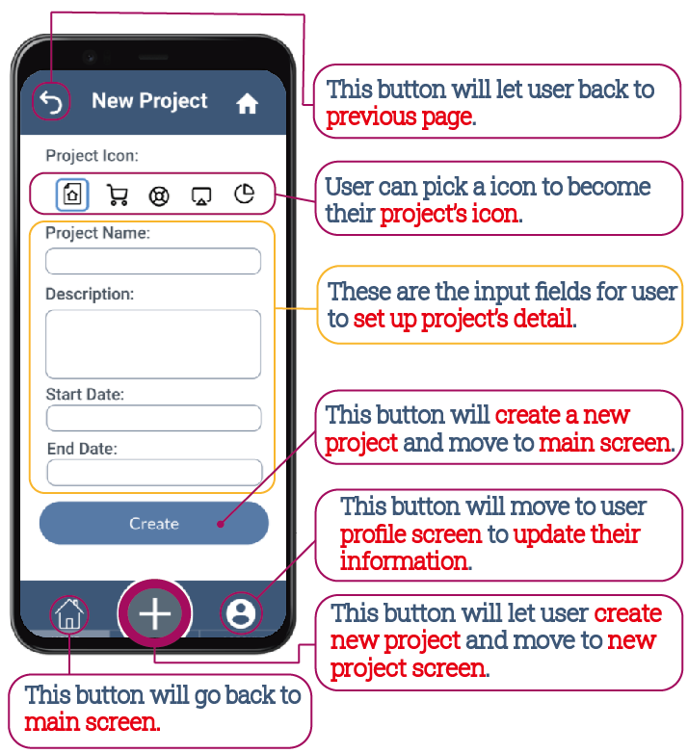

*Figure 4.6: New Project Screen*

#### Project Detail Screen

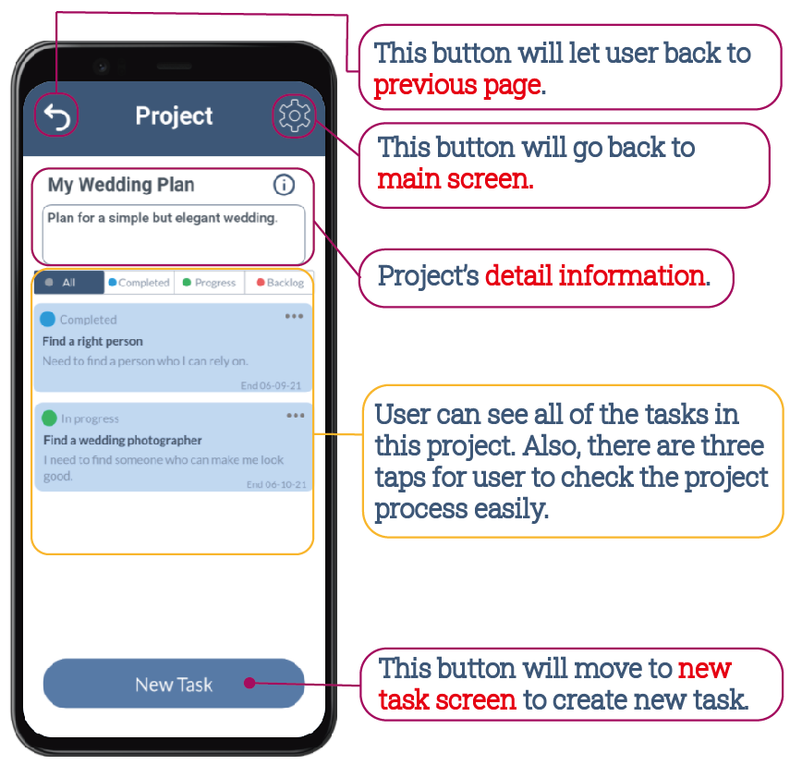

*Figure 4.7: Project Detail Screen*

#### Project Detail Edit Screen

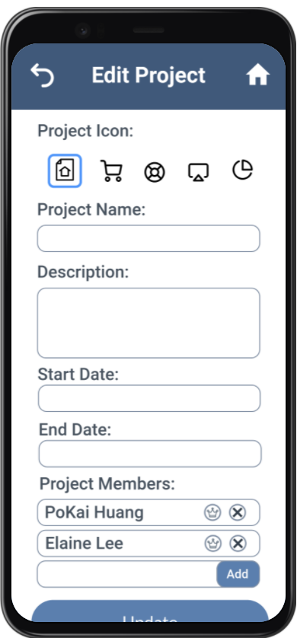

*Figure 4.8: Project Detail Edit Screen*

#### New Task Screen

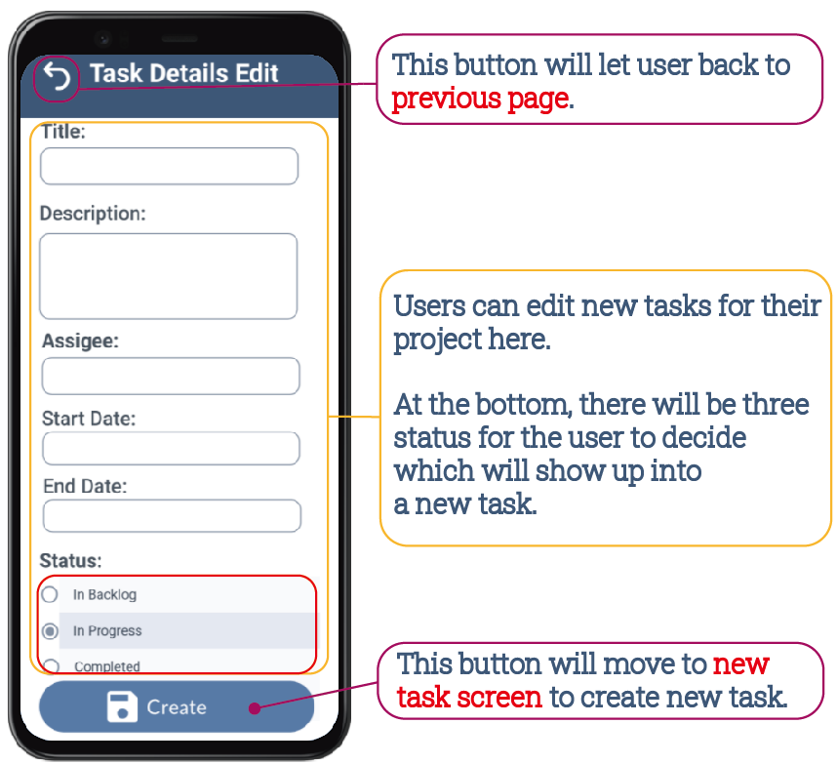

*Figure 4.9: New Task Screen*

# Chapter V: Project Class Diagrams

### Model and Repository Classes

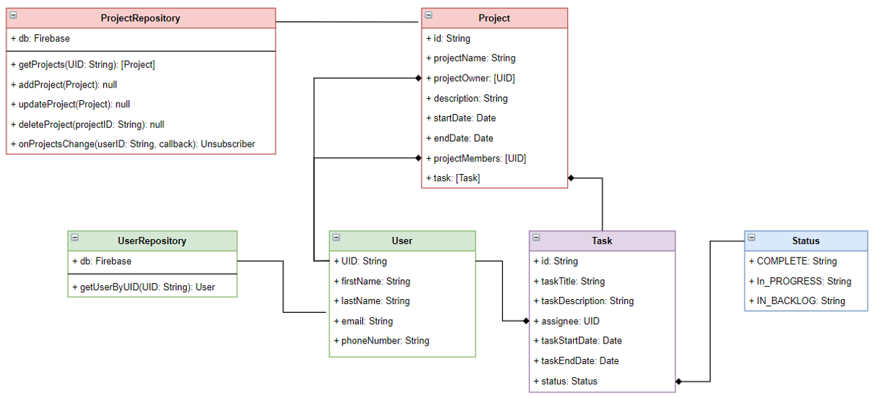*Figure 5.1: Model and Repository Class Diagram*

Figure 4.1 shows a class diagram of the User, Project, and Task model classes and the ProjectRespository and UserRespository classes.

The User class contains user information such as first name, last name, email, and phone number. In addition, each user is identified by their user id (UID), which is auto generated by Firebase Authentication upon user registration.

The Project class contains information about a project, such as a project name, description, start date and end date. A project also includes arrays of project owners, project members and tasks. Project owners and project members are kept in the collections using their UIDs. Tasks will be stored in a project as an array of task objects.

The Task class contains information such as task title, description, start date and end date. Each task has an assignee, which is identified by the assignee’s UID. In addition, each task can be in status either of *backlog, in process* or *completed.*

Both the ProjectRespository and UserRespository classes communicate with the firebase. The ProjectRespository performs CRUD operations to get, create, update, and delete projects in the database. The UserRespository queries user information from the database.

### View Classes

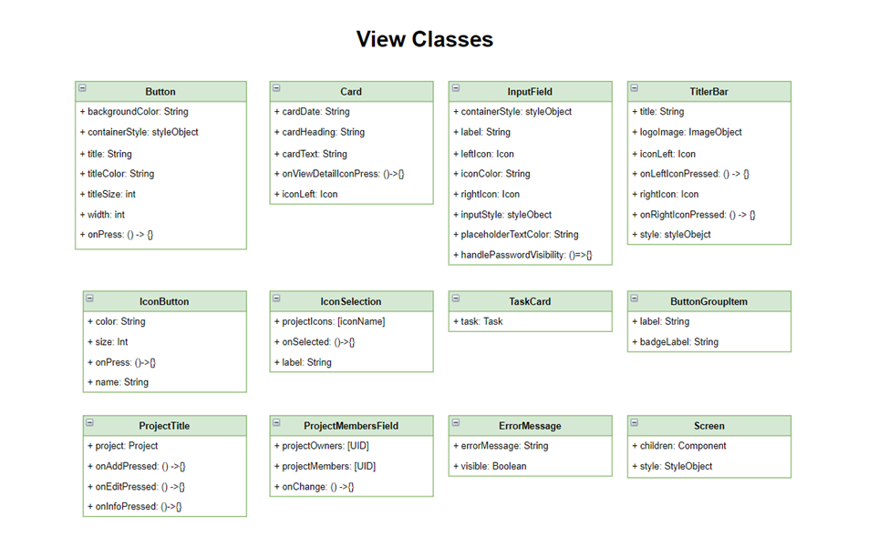

Figure 5.3.1 Classes Components-1



Figure 5.3.2 Classes Components-2

Figures 5.3.1 and 5.3.2 show the reusable UI components used in our applications. These UI components include elements such as buttons, cards, input fields etc.

### Controller Classes

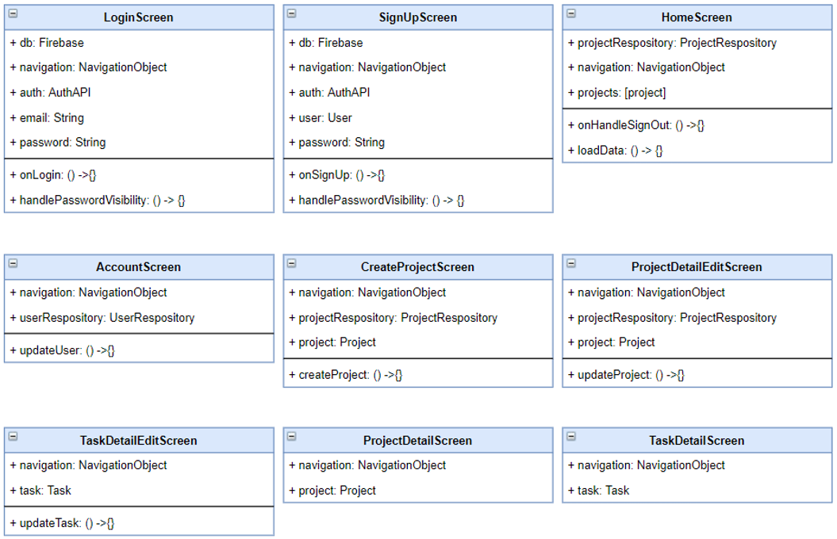*Figure 5.4: Controller Classes*

Figure 5.4 shows the controllers (or screens) of the application. A controller contains both data (or instances of model classes) and handles application business logic. All screens are controllers.

The login screen class captures email and password from the user and performs login operation using the auth API service. The SignUpScreen class captures user information and performs a sign-up function for new users. The HomeScreen queries all projects that a user belongs to using the ProjectRespository class. The AccountScreen queries user information using the UserRespository and performs updates on user information. The CreateProjectScreen creates a new project. Finally, the ProjectDetailEditScreen and TaskDetailEditScreen perform update operations on project and task, respectively.

# Chapter VI: Test Results

### User Testing

To examine our mobile application in more depth, we invited the team’s family members to conduct a comprehensive user test of the mobile application. The test content includes login test, signup test, creating a new project, adding new tasks, adding project members into the project, and other tests. The following are the results of our user test.

#### Testing 1: Login to the application

Objective: To make sure the login form is working correctly.

|  |  |  |  |  |
| --- | --- | --- | --- | --- |
| **No** | **Even** | **Attribute and Value** | **Expected Result** | **Result** |
| 1 | Authenticate user login after click  Login button on login form with correct input data. | Login Email:  [popo@gmail.com](mailto:popo@gmail.com)  Password:  123456 (Correct) | Successfully login to the main page. | Pass |
| 2 | Authenticate user login after click  Login button on login form with incorrect password input data. | Login Email:  [popo@gmail.com](mailto:popo@gmail.com)  Password:  1234 (Incorrect) | Failed to login and show the error message. | Pass |
| 3 | Authenticate user login after click  Login button on login form with incorrect email input data. | Login Email:  [popo@gmail.m](mailto:popo@gmail.m) (Incorrect)  Password:  123456 | Failed to login and show the error message. | Pass |
| 4 | Authenticate user login after click  Login button on login form with null email input value. | Login Email:  [Null](mailto:popo@gmail.com)  Password:  123456 | Failed to login and show the error message. | Pass |
| 5 | Authenticate user login after click  Login button on login form with null password input value. | Login Email:  [popo@gmail.com](mailto:popo@gmail.com)  Password:  Null | Failed to login and show the error message. | Pass |

Table 6.1 login testing

#### Testing 2: Create Account

Testing Objective: To make sure the signup form is working correctly.

|  |  |  |  |  |
| --- | --- | --- | --- | --- |
| **No** | **Even** | **Attribute and Value** | **Expected Result** | **Result** |
| 1 | Authenticate user signup after click  Signup button on signup form with correct input data. | First Name: PoKai Last Name: Huang  Login Email:  [popo@gmail.com](mailto:popo@gmail.com)  Password:  123456 (Correct) | Successfully create the account and move to main page | Pass |
| 2 | Authenticate user signup after click  Signup button on signup form with incorrect input data. | First Name: PoKai Last Name: Huang  Login Email:  [popo@gmail.com](mailto:popo@gmail.com)  Password:  123 (Incorrect) | Failed to login and show the error message. | Pass |
| 3 | Authenticate user login after click  Login button on login form with incorrect email input data. | Login Email:  [popo@gmail.m](mailto:popo@gmail.m) (Incorrect)  Password:  123456 | Failed to login and show the error message. | Pass |
| 4 | Authenticate user login after click  Login button on login form with null email input value. | Login Email:  [Null](mailto:popo@gmail.com)  Password:  123456 | Failed to login and show the error message. | Pass |
| 5 | Authenticate user login after click  Login button on login form with null password input value. | Login Email:  [popo@gmail.com](mailto:popo@gmail.com)  Password:  Null | Failed to login and show the error message. | Pass |

Table 6.2 signup testing

#### Testing 3: Create a new project

Testing Objective: To make sure the new project form is working correctly.

|  |  |  |  |  |
| --- | --- | --- | --- | --- |
| **No** | **Even** | **Attribute and Value** | **Expected Result** | **Result** |
| 1 | Create new project on new project page with correct input data. | Project Name: Testing App  Project Description: Testing New project  Start Date:  2021-12-07  End Date:  2021-12-09 | Successfully create the project and move to main page | Pass |
| 2 | Create new project on new project page with null project name input value. | Project Name: Null  Project Description: Testing New project  Start Date:  2021-12-07  End Date:  2021-12-09 | Failed to create and show the error message. | Pass |
| 3 | Create new project on new project page with null project description input value. | Project Name: Testing App  Project Description: Null  Start Date:  2021-12-07  End Date:  2021-12-09 | Failed to create and show the error message. | Pass |
| 4 | Create new project on new project page with incorrect date input value. | Project Name: Testing App  Project Description: Testing New project  Start Date:  2021-12-07  End Date:  2021-12-06 | Failed to create and show the error message. | Pass |

Table 6.3 create new project testing

#### Testing 4: Edit Project

Testing Objective: To make sure the edit project form is working correctly.

|  |  |  |  |  |
| --- | --- | --- | --- | --- |
| **No** | **Even** | **Attribute and Value** | **Expected Result** | **Result** |
| 1 | Edit project on edit project page with correct input data. | Project Name: Testing App  Project Description: Testing New project  Start Date:  2021-12-07  End Date:  2021-12-09  New Member:  elaine@gmail.com | Successfully edit the project and move to main page | Pass |
| 2 | Update project on edit project page with null project name input value. | Project Name: Null  Project Description: Testing New project  Start Date:  2021-12-07  End Date:  2021-12-09  New Member:  elaine@gmail.com | Failed to save and show the error message. | Pass |
| 3 | Update project on edit project page with null project description input value. | Project Name: Testing App  Project Description: Null  Start Date:  2021-12-07  End Date:  2021-12-09  New Member:  elaine@gmail.com | Failed to save and show the error message. | Pass |
| 4 | Update project on edit project page with incorrect date input value. | Project Name: Testing App  Project Description: Testing New project  Start Date:  2021-12-07  End Date:  2021-12-06  New Member:  elaine@gmail.com | Failed to save and show the error message. | Pass |
| 5 | Update project on edit project page with incorrect user’s email input value | Project Name: Testing App  Project Description: Testing New project  Start Date:  2021-12-07  End Date:  2021-12-09  New Member:  elaine@gmail | Failed to save and show the error message. | Pass |

Table 6.4 Edit project testing

#### Testing 5: Create New Task

Testing Objective: To make sure the create new task form is working correctly.

|  |  |  |  |  |
| --- | --- | --- | --- | --- |
| **No** | **Even** | **Attribute and Value** | **Expected Result** | **Result** |
| 1 | Create new project task on create new task page with correct input data. | Task Name:  Testing New Task  Task Description: Testing New Task  Select An Assignee:  Elaine Lee  Start Date:  2021-12-07  End Date:  2021-12-09  Status:  In Progress | Successfully create the project task and move to project detail page. | Pass |
| 2 | Create new project task on create new task page with null task name input value. | Task Name:  Null  Task Description: Testing New Task  Select An Assignee:  Elaine Lee  Start Date:  2021-12-07  End Date:  2021-12-09  Status:  In Progress | Failed to create and show the error message. | Pass |
| 3 | Create new project task on create new task page with null task description input value. | Task Name:  Testing New Task Task Description: Null  Select An Assignee:  Elaine Lee  Start Date:  2021-12-07  End Date:  2021-12-09  Status:  In Progress | Failed to create and show the error message. | Pass |
| 4 | Create new project task on create new task page with incorrect date input value. | Task Name:  Testing New Task Task Description: Testing New Task  Select An Assignee:  Elaine Lee  Start Date:  2021-12-07  End Date:  2021-12-06  Status:  In Progress | Failed to create and show the error message. | Pass |
| 5 | Create new project task on create new task page with no select assignee value | Task Name:  Testing New Task  Task Description: Testing New Task  Select An Assignee:  Null  Start Date:  2021-12-07  End Date:  2021-12-09  Status:  In Progress | Failed to create and show the error message. | Pass |

Table 6.5 Create new task testing

#### Testing 6: Edit Project Task

Testing Objective: To make sure the task details edit form is working correctly.

|  |  |  |  |  |
| --- | --- | --- | --- | --- |
| **No** | **Even** | **Attribute and Value** | **Expected Result** | **Result** |
| 1 | Update project task on task details edit page with correct input data. | Task Name:  Testing New Task-1  Task Description: Testing New Task-2  Select An Assignee:  Elaine Lee  Start Date:  2021-12-07  End Date:  2021-12-08  Status:  Completed | Successfully update the project task and move to project detail page. | Pass |
| 2 | Update project task on task details edit page with null task name input value. | Task Name:  Null  Task Description: Testing New Task-2  Select An Assignee:  Elaine Lee  Start Date:  2021-12-07  End Date:  2021-12-08  Status:  Completed | Failed to update and show the error message. | Pass |
| 3 | Update project task on task details edit page with null task description input value. | Task Name:  Testing New Task-1  Task Description: Null  Select An Assignee:  Elaine Lee  Start Date:  2021-12-07  End Date:  2021-12-08  Status:  Completed | Failed to update and show the error message. | Pass |
| 4 | Update project task on task details edit page with incorrect date input value. | Task Name:  Testing New Task-1  Task Description: Testing New Task-2  Select An Assignee:  Elaine Lee  Start Date:  2021-12-07  End Date:  2021-12-04  Status:  Completed | Failed to update and show the error message. | Pass |

Table 6.6 update project task testing

# Chapter VII: User Guide

### Installation Guide

#### Step 1: Install Expo Go

To install Plan-It-Right, users need to first install Expo Go on their mobile phones. To install the Expo Go, users can go to the following links and complete the installation process:

**For Android devices :** <https://play.google.com/store/apps/details?id=host.exp.exponent>

**For iOS devices :**

<https://apps.apple.com/ca/app/expo-go/id982107779>

#### Step 2: Install Plan-It-Right

**For Android devices:**

1. Firstly, users need to have Expo Go application installed in their device (*see Step 1: Install Expo Go).*

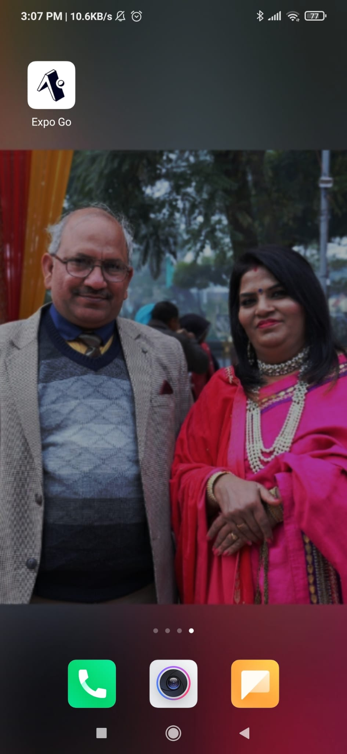

*Figure 7.1: Expo Go Application Icon*

1. To start the application, users need to click on the following link: <https://expo.dev/@eric1162004/Plan-It-Right>

After user clicks this link, they will be directed to their browser to open the link in Expo Go App (*see Figure 7.2*).

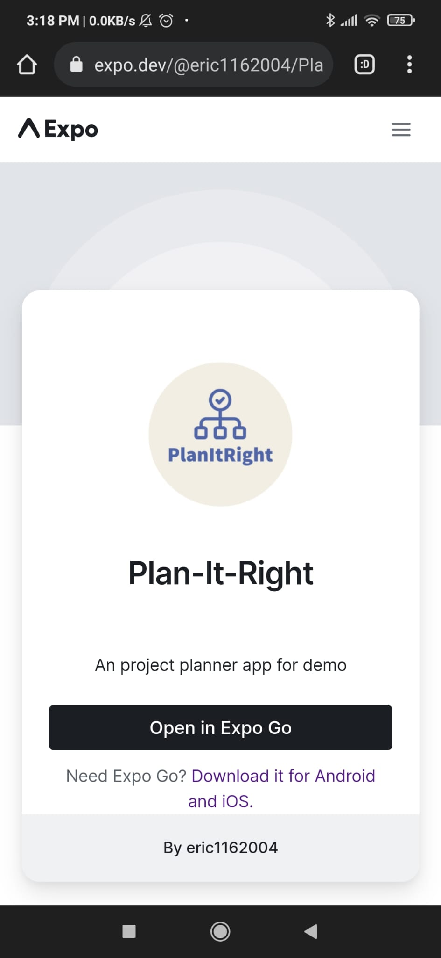

*Figure 7.2: Expo Webpage to download Plan-It-Right*

1. User needs to click “Open in Expo Go” button which will directly open the Plan-It-Right app in Expo Go*.*

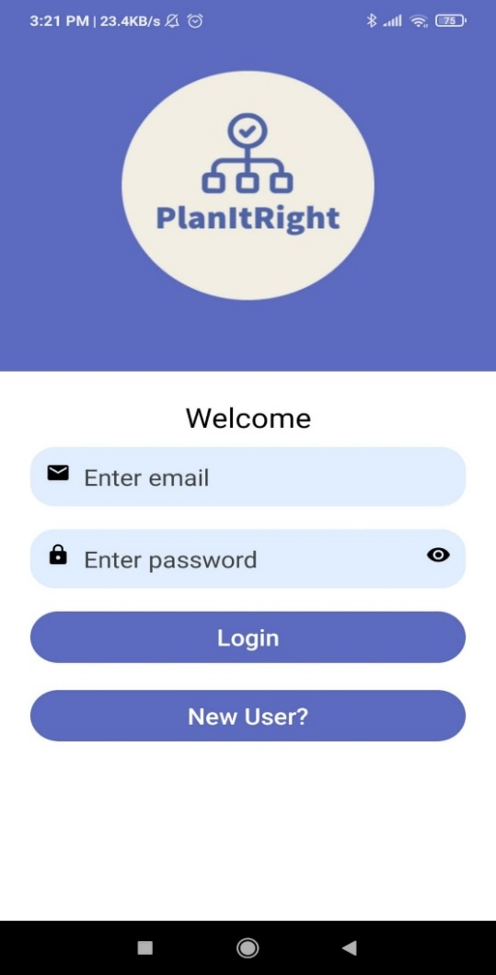

*Figure 7.3: Plan-It-Right Application Welcome Screen*

**For iOS devices:**

1. Users need to download the project source code from our GitHub Repository:

<https://github.com/pokai-huang0828/PlanItRight-project.git>

1. After unzipping the folder, users need to open the folder in command line and write `npm start`

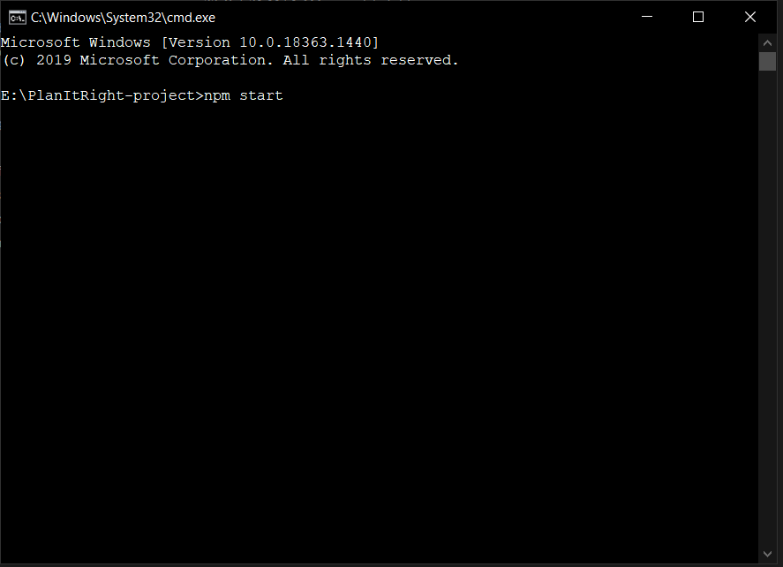

*Figure 7.4: Command terminal to start the Plan-It-Right project*

1. The command will run and there will be an attempt by expo to open the browser automatically as shown in Figure 7.5.

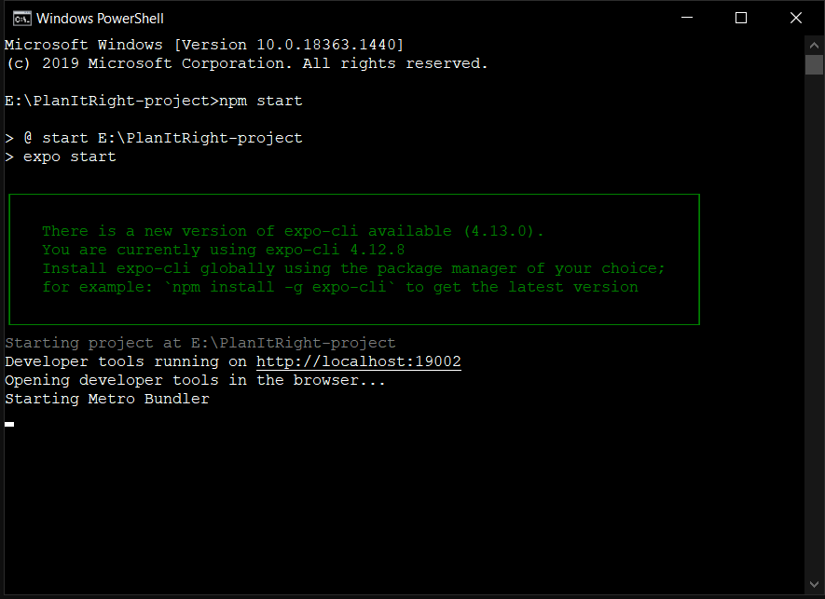

*Figure 7.5: `npm start` command running*

1. This will open their browser from where they can scan the QR code in expo go app. After that, the app will successfully run on their device.

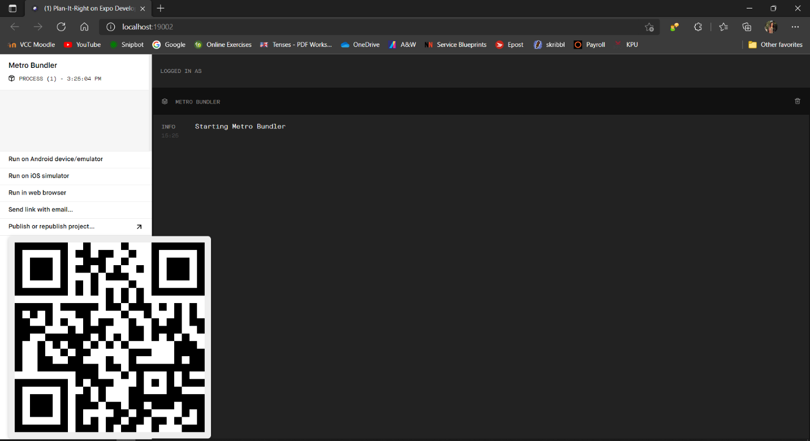

*Figure 7.6: Metro Bundler with QR code*

### Operational Guide

#### Creating a New Account

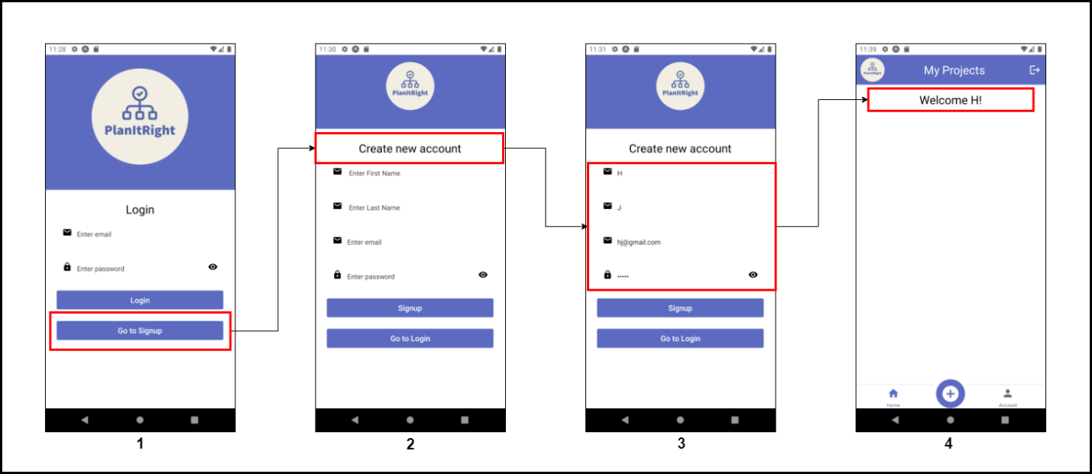*Figure 7.7: How to create a new account.*

1. To create a new account, user needs to click on “Go to Signup” button.
2. Create new account screen will open.
3. User needs to fill in the details, their first name, last name, email address and a password. After that user can click “signup” in order to create a new account.
4. After signing up, main screen will open.

#### Logging into the application

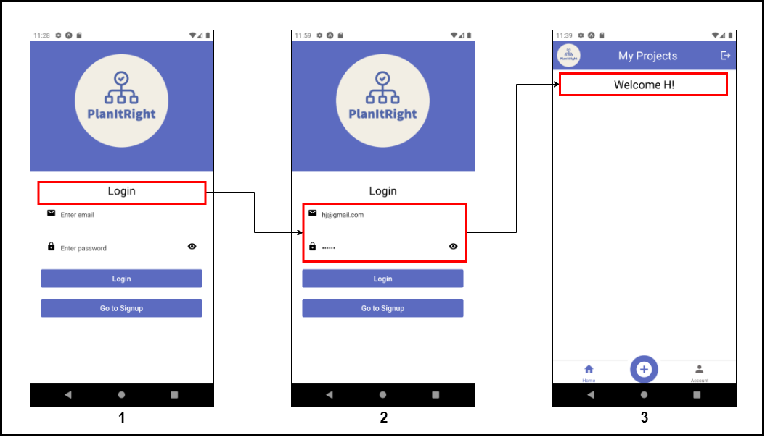

*Figure 7.8: How to login into existing account.*

1. User needs to run the app which will open welcome screen.
2. After that, user can fill in their credentials and click on “Login” button.
3. After logging up, main screen will open.

#### Logging out of the application

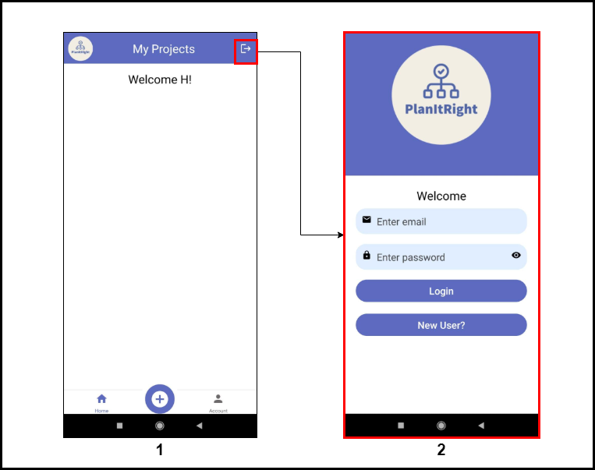

*Figure 7.9: Logging out of the application*

1. On the Main screen, user needs to click on the “exit” button (see Figure 7.9).
2. User will be logged out of the application and will land on welcome Screen.

#### Creating a New Project

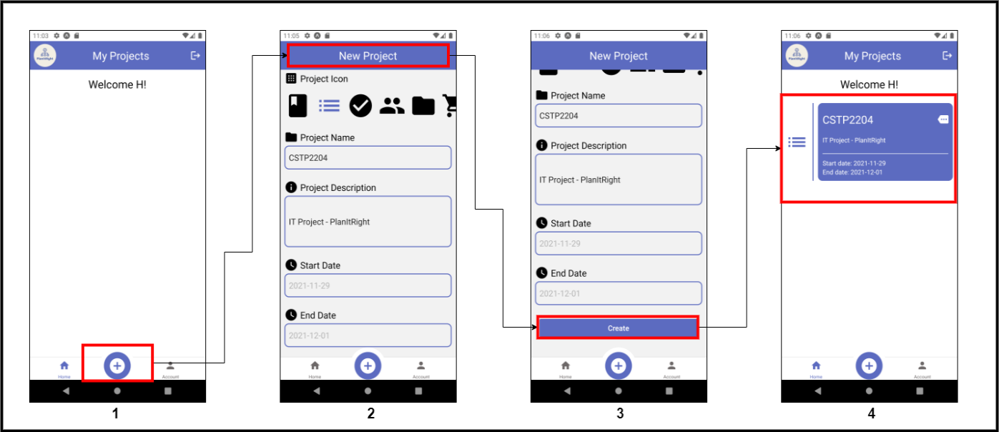

*Figure 7.10: How to create a new project.*

1. After logging in, on the Main screen, user needs to click on the “+” button, i.e., create a new project button.
2. New project screen will open.
3. User needs to fill in the details and then click “Create” button.
4. A new project will be created and displayed on Main screen.

#### Viewing Project Details

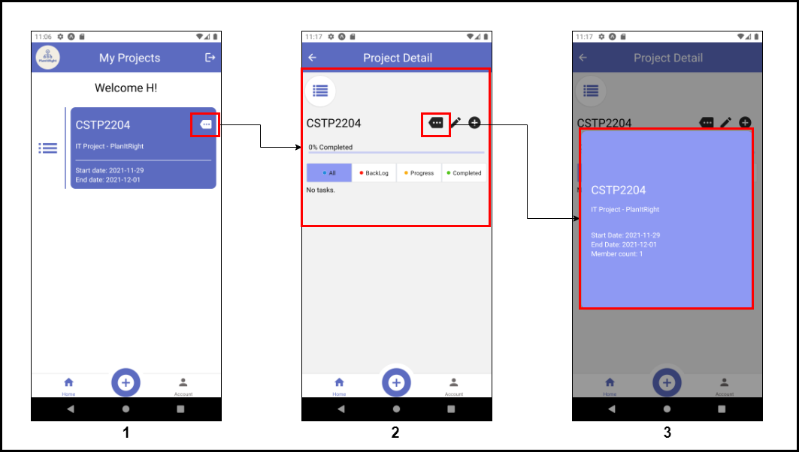

*Figure 7.11: How to view a project.*

1. A project can be viewed on Main screen, however if user needs to see the details of the project, they can click details button as shown in figure 7.11 Image 1.
2. This button will open Project details page and here, user needs to click the same button again in order to view project description.
3. Project description card will pop-up.

#### Updating a Project

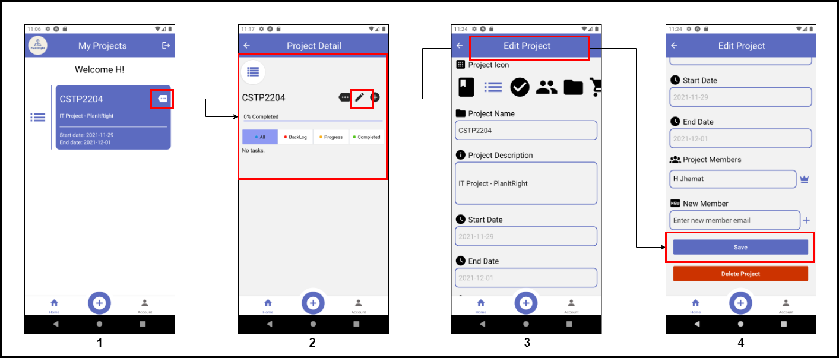*Figure 7.12: How to update a project*

1. The list of all projects can be seen on the Main screen. Here, a user can click on “Details” button to go into product details.
2. In project details page, user needs to click on “pencil icon” as shown in Figure 7.12 Image 2.
3. This will open Edit project page where a user can edit their details.
4. After that, to save the changes the user needs to click the save button.

#### Adding a New Project Member

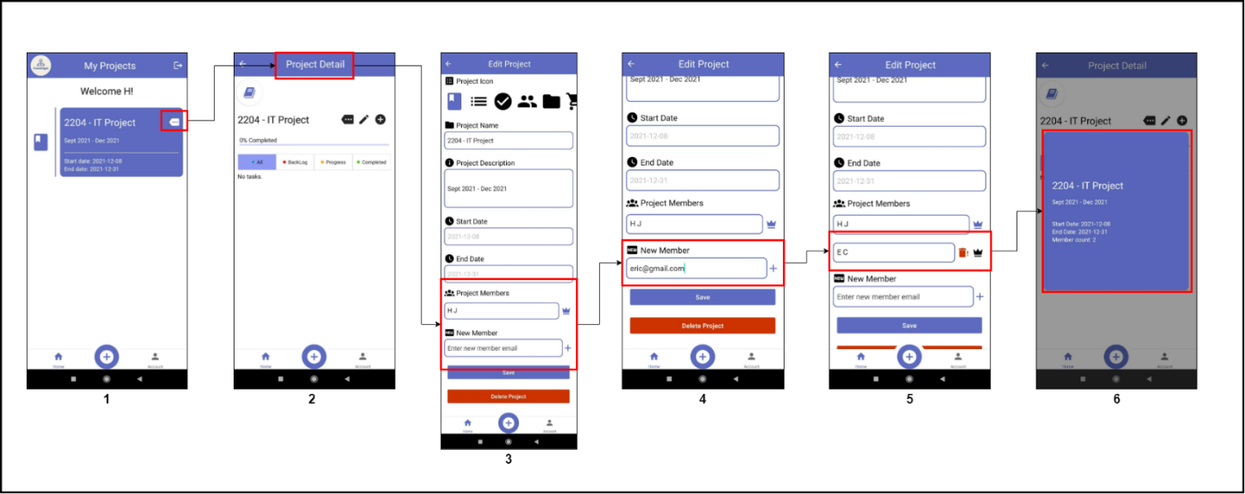

*Figure 7.13: Adding a new project member to a project*

1. From the main screen, user can select the project they want to add a new member to and then click “Details” button.
2. In project details screen, user can click on “pencil” icon to edit the project.
3. User needs to scroll down to “Project Members” section.
4. Here, in “New Member” column, user can add the email of the new member and then click “+” sign.
5. The new project member will be added. After that, user can save the settings by clicking on “save” button.
6. User can view the number of members in project details card (see Figure 7.11 for the steps).

#### Promoting a Project member to Project owner

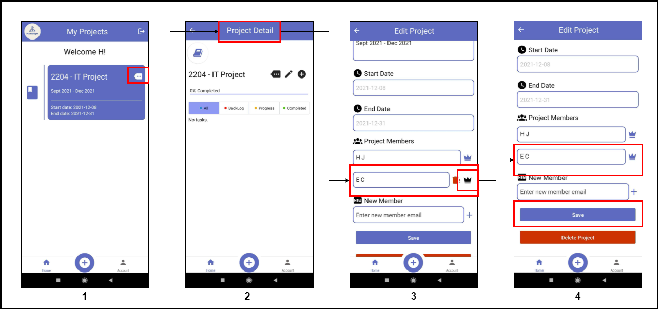

*Figure 7.14: Promoting a project member to project owner*

1. From the main screen, user can select the project and then click “Details” button.
2. In project details screen, user can click on “pencil” icon to edit the project.
3. User needs to scroll down to “Project Members” section and then click “crown” icon i.e., in front of the project member name in order to make them the owner.
4. The “crown” icon will appear in front of project member’s name which signifies that the member is an owner now. After that, user can save the settings by clicking on “save” button.

#### Deleting a Project

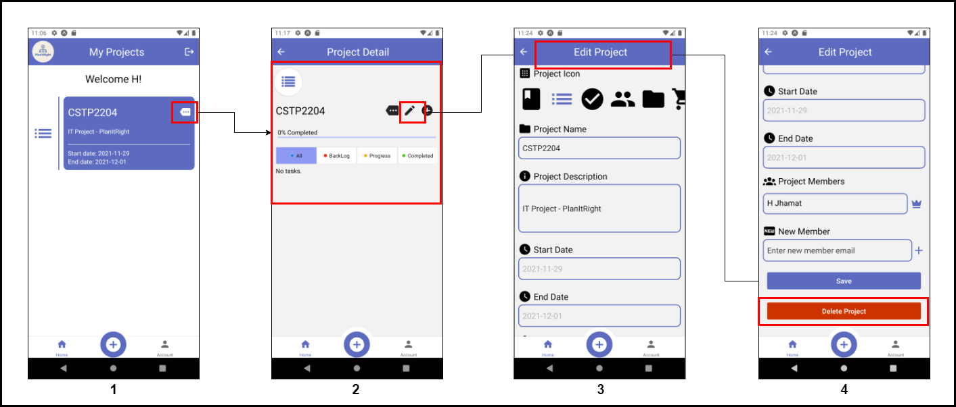*Figure 7.15: How to Delete a Project*

1. The list of all projects can be seen on the Main screen. Here, a user can click on “Details” button to go into product details.
2. In project details page, user needs to click on “pencil icon” as shown in Figure 7.15 Image 2.
3. This will open Edit project page where a user can Delete their project.
4. At the bottom of the page, there is a “Delete Project” button that a user can click to delete the project.

#### Creating a Task

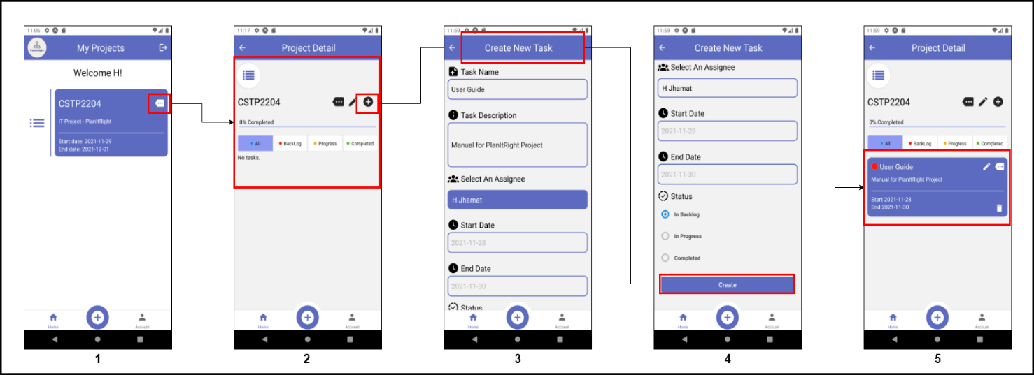 *Figure 7.16: how to Create a Task*

1. To create a task, the user needs to open project details by clicking the details icon.
2. User can click “+” button to open “create new task” page.
3. Here, the user needs to give details to the task like a task name, task description, start and end date and the project status.
4. After filling in the details, user can click on “create” button to create a task.
5. A task can be viewed from a project details screen.

#### Viewing Task Details

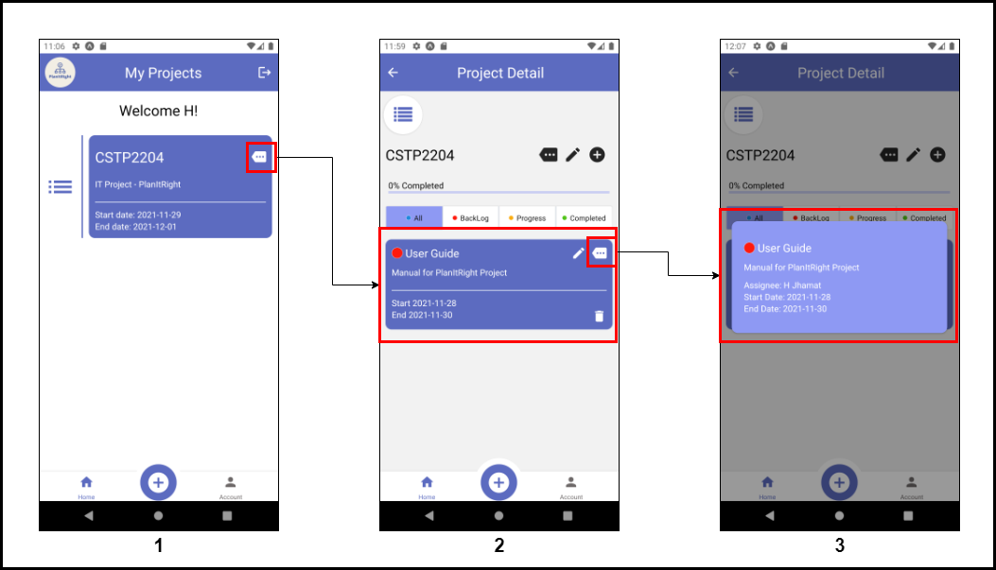*Figure 7.17: How to View a Task*

1. A task can be viewed by opening the project details page.
2. To view task details, the user needs to click the details button present on that task card, as shown in Figure 7.17 Image 2.
3. The task details card will pop up which will include the task name, description, assignee, start and end date.

#### Updating a Task

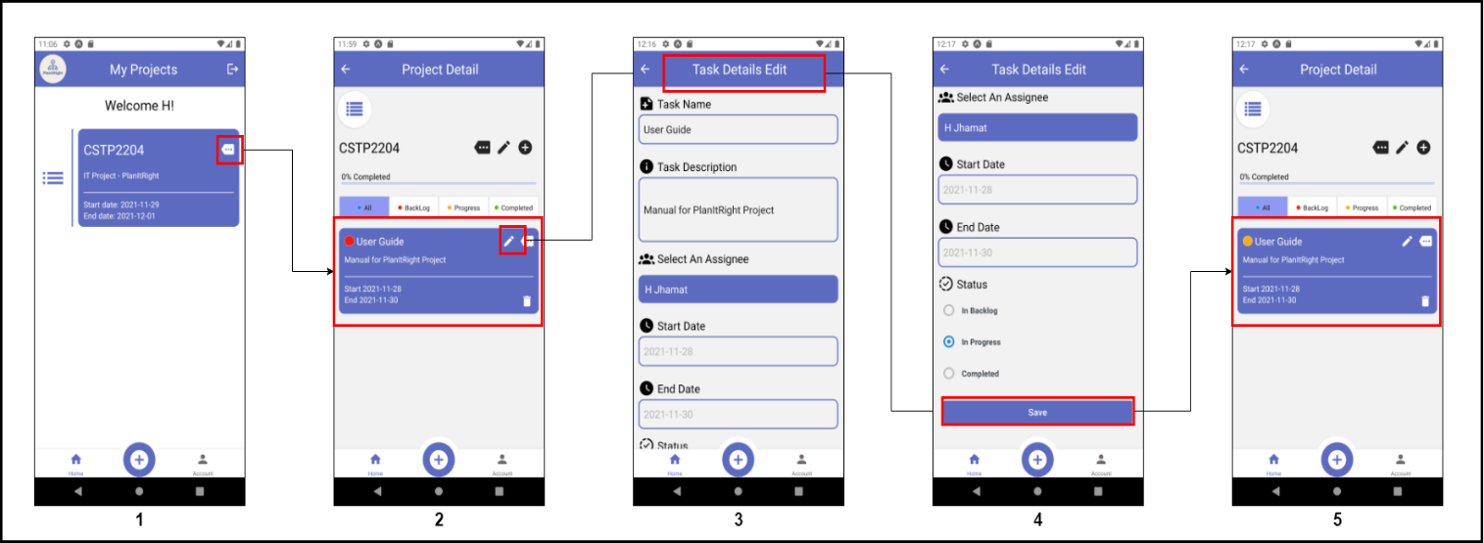*Figure 7.18: How to Update a Task*

1. To update our task the user needs to view project details.
2. In the project details page, the list of tasks is present. Here, to update any task user needs to click on the pencil icon of that task.
3. This will open the project details edit page.
4. After making changes to the project details, the user can click on the save button.
5. The change can be immediately seen in the task list.

#### Changing Task Status

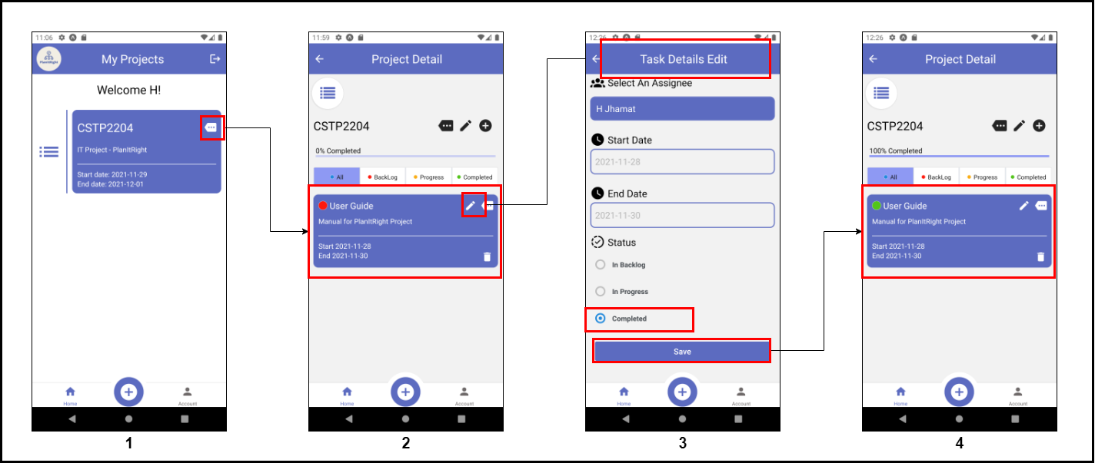 *Figure 7.18: How to mark task as “Complete”*

1. From the main screen, the user needs to open project details page.
2. Here, the user needs to select a task that they want to mark as complete and then click on the pencil icon of the task as shown in 7.18 Image 2.
3. This will open task details edit page, where user can go to status option and mark task as completed and then save.
4. Now, a green circle will appear on the task, which will signify that the task has been completed.

#### How to Modify Task Status

##### Changing Task Status to Backlog

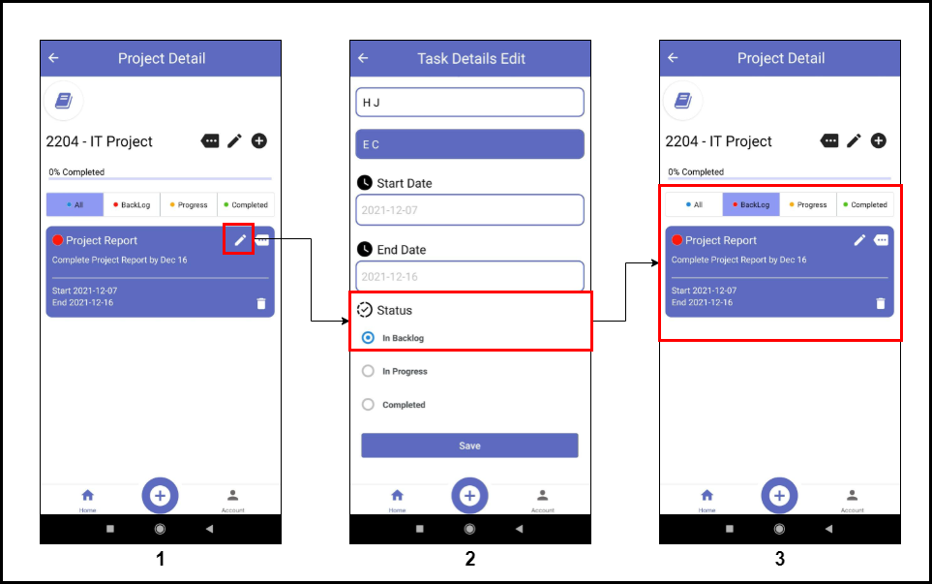

*Figure 7.19: Changing task status to red*

1. All the tasks can be viewed in “All” tab in the project details screen. To change status of the task, user needs to click “pencil” icon.
2. In task details edit screen, user can go to the status section and mark the task as “In Backlog” in order to add the task to “Backlog/ Red” tab and then save the changes.
3. The task can be viewed in “Backlog” tab now (Backlog tab states that the task has not been started yet).

##### Changing Task Status to In Progress

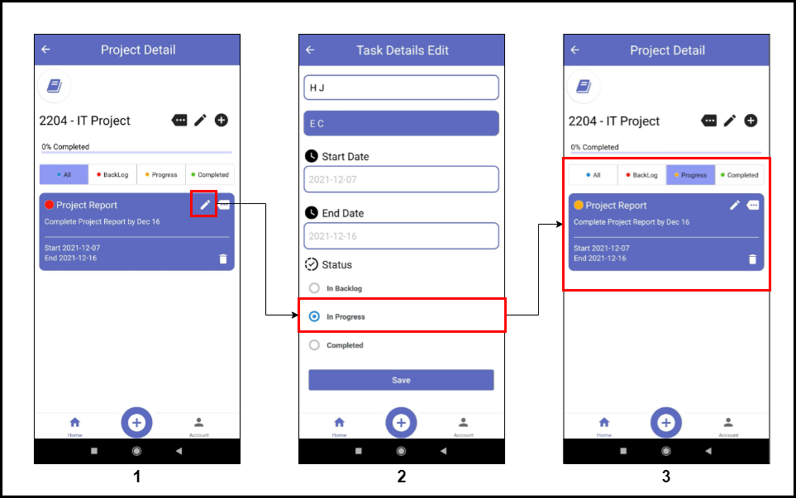

*Figure 7.20: Changing task status to yellow*

1. All the tasks can be viewed in “All” tab in the project details screen. To change status of the task, user needs to click “pencil” icon.
2. In task details edit screen, user can go to Status section and mark the task as “In Progress” in order to add the task to “Progress” tab and then save the changes.
3. The task can be viewed in “Progress” tab now (Progress tab states that the task has been started and there is some progress).

##### Changing Task Status to Completed

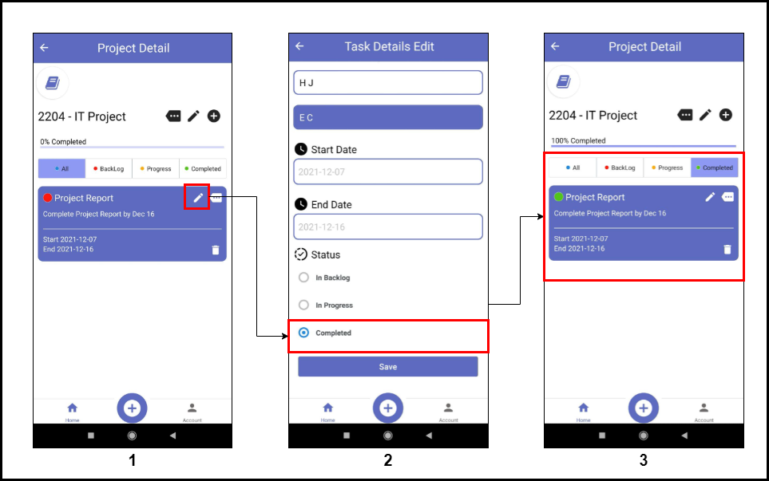

Figure 7.21: Changing task status to green

1. All the tasks can be viewed in “All” tab in the project details screen. To change status of the task, user needs to click “pencil” icon.
2. In task details edit screen, user can go to Status section and mark the task as “Completed” in order to add the task to “Completed” tab and then save the changes.
3. The task can be viewed in “Completed” tab now (Complete tab states that the task has been completed).

#### Deleting a Task

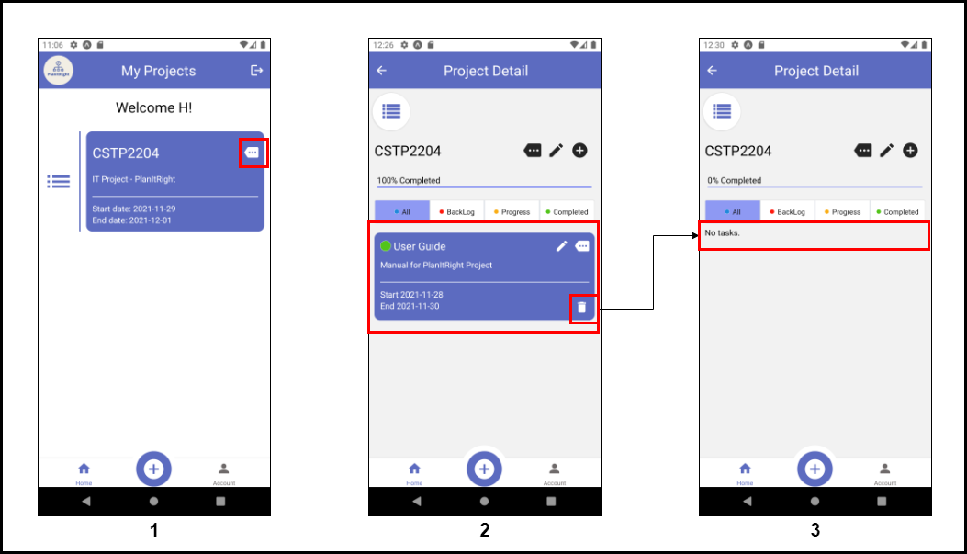

*Figure 7.22: how to Delete a Task*

1. From the main screen, the user needs to open project details page.
2. Here, the delete button is present on the bottom-right side of the task card. Users can click that button in order to delete the task.
3. The change can be immediately seen on the task list.

# Chapter VII: Conclusion

### Lessons Learned

This project has been a meaningful learning experience for our team. We have learned many valuable skills from applying project management skills, drafting technical reports, and developing a mobile application in a group setting.

During the planning phase, we had little idea of how to manage a mobile application project, such as how to define a project scope, how to construct a time schedule, and how to communicate with other team members about the project progress and keep track of each other’s progress. Fortunately, our instructor has taught us to use WBS to define our tasks and Gantt Chart to establish a time schedule for the project. Those tools helped us to break down our work into tasks and set a realistic timeline.

We have also found Kanban board to be a helpful collaboration tool to communicate the team progress with one another. A Kanban board allows each team member to observe what tasks have already been completed and what tasks are delayed. Therefore, we can keep each team member accountable for their responsibilities and meeting the deadlines.

Prior to the course, we do not have any experience in authoring technical reports for application development projects. During this project, our team has the opportunities to author technical reports such as the specification requirements document (SRD), software project management plan (SPMP) and software description document (SDD). The technical report references provided by our instructor were extremely helpful.

Finally, we have learned to utilize some useful mobile application development tools such as React Native, Expo, and Firebase. During the application development phase, our instructor gave us a lot of practical insights on how to set up our mobile application development environment using Expo and to create UI components in React Native. In addition, our team had also found some useful internet resources on how to connect our mobile application to the firebase backend.

### Challenge

During our mobile application project, our team has faced different challenges in terms of technical difficulties.

One of the technical difficulties was platform incompatibility. We wished to make our application to work both on the mobile and web platforms. However, due to a limited browser support features from Expo, some of our application functionalities were not working properly in the browser. Therefore, our team put our effort in the mobile platform instead.

Another technical difficulty was to devise a convenient installation process for the IOS users. We wished to allow the IOS users be able to download our application from our public repository in Expo Go. We thought this would be a convenient way for the IOS users to install our application. Unfortunately, due to some constraints from the IOS platform, IOS users are not able to download our application from our public repository in Expo. Instead, IOS users will have to download our project codes from our GitHub repository directly and install the application by running the project codes in their local computer. We are still trying to figure out a convenient way for IOS users to install our application and we hope there will be a solution in the future.

The process of developing a mobile application was exciting and challenging for our team as we had never done any mobile development before. We are pleased that we have achieved our objective of delivering a mobile application that can help users to manage their projects and keep track of their daily tasks.

### Future Improvements

Our team believes our Plan-It-Right application still has plenty of room for improvement. We want to add more capabilities to our application, for example, adding features such as task deadline reminders, new task notifications and instant messaging functions. We believe that these features will be useful to our users and help them in managing their projects.

# Chapter VIII: References

* *Firebase*. (n.d.). Retrieved from https://firebase.google.com/docs/firestore/quotas: https://firebase.google.com/docs/firestore/quotas
* *Introduction to Expo*. (n.d.). Retrieved from Expo: https://docs.expo.dev/
* Rawal, K. (2018, June 12). *12 Most Popular React Native Development Tools*. Retrieved from codementor: https://www.codementor.io/@kapilrawal/12-most-popular-react-native-development-tools-kf45eu4uh

# Chapter lX: Appendices

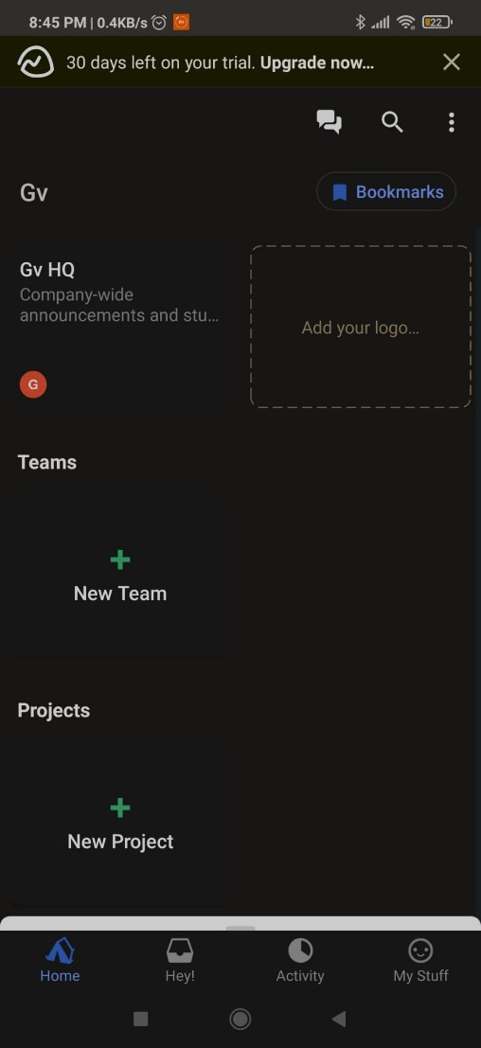

*APPEXDIX1.1 Main Screen of Basecamp 3 App*

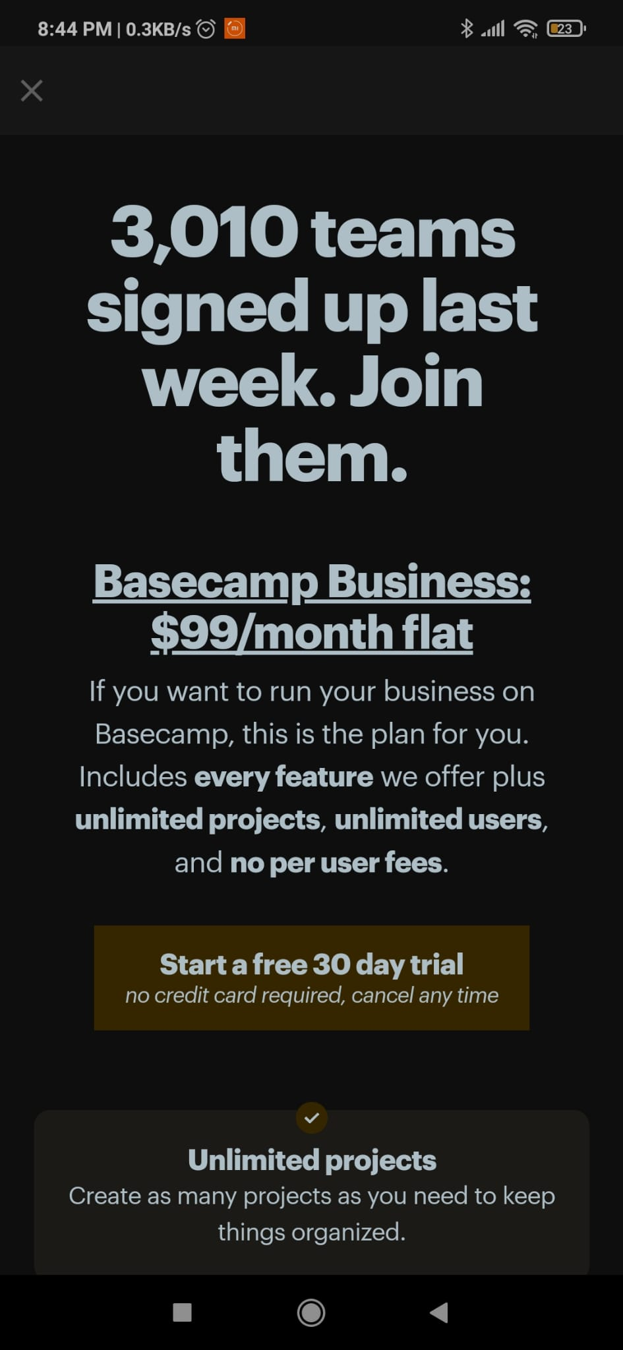

*APPEXDIX1.2 Subscription Plan for Basecamp 3*

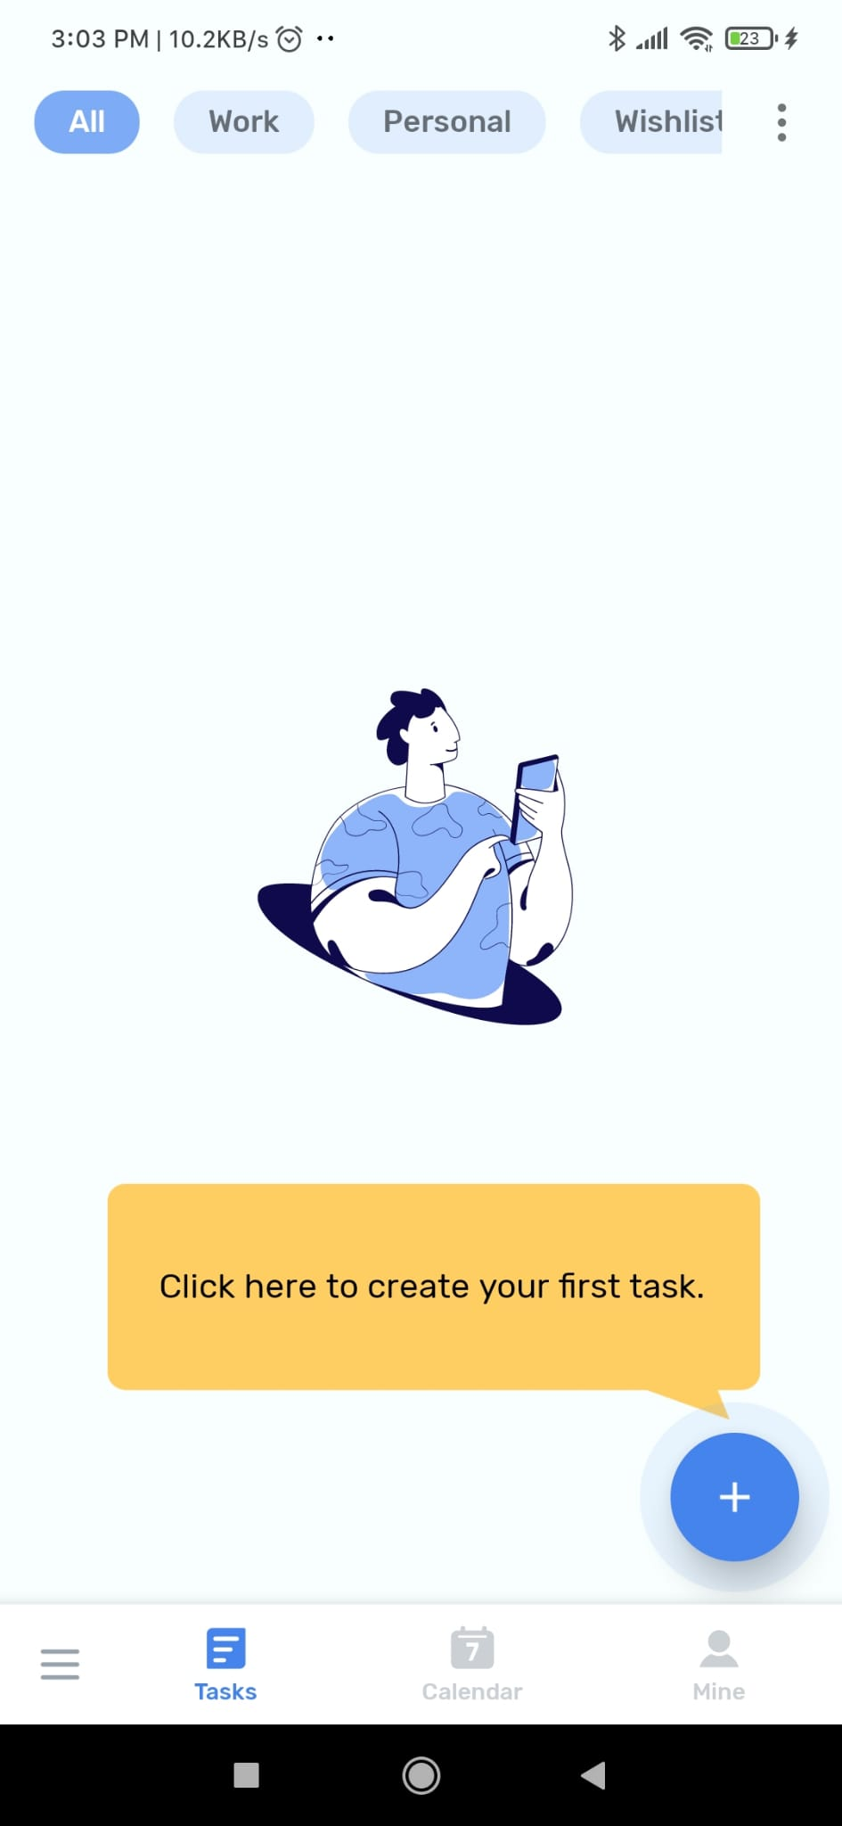

*APPEXDIX1.3 Main Screen of* *To-Do List*

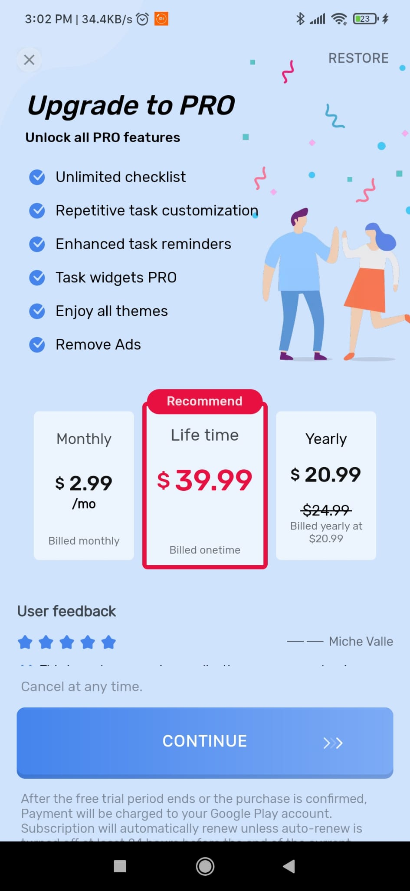

*APPEXDIX1.4 Subscription plan for To-Do List*

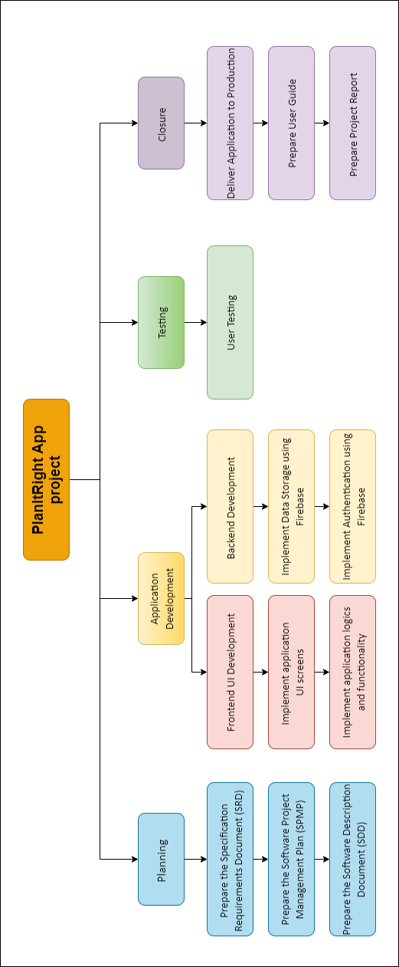  
*APPEXDIX 2.1: WBS Diagram*

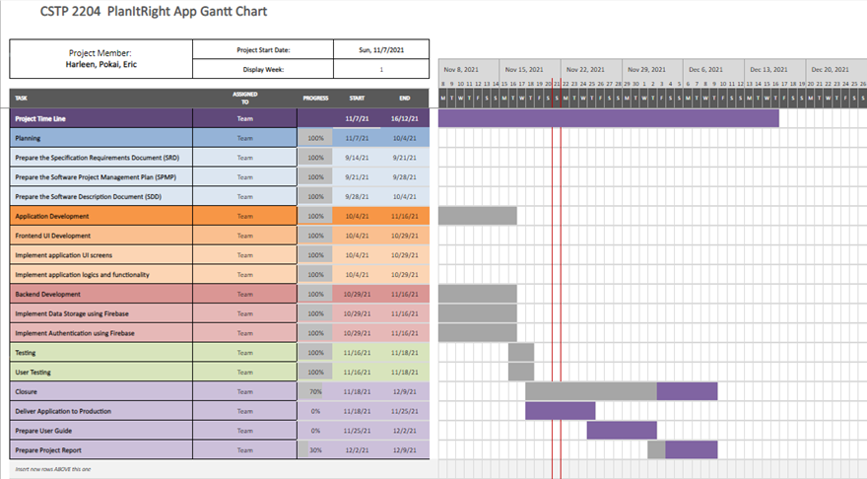

*APPEXDIX 2.2* : Gantt Chart